# Introduction

Exercise is critical for good health. But many people sit too much and move too little. Worse yet, many people do not even know that they are not getting enough exercise. Using accelerometer in the mobile phones, we can provide data for people so they can achieve healthy level of physical activity and inactivity.

Therefore our application will generate data for users to reflect, monitor and improve their levels of physical activity by providing ways for users to be motivated and track their level of physical activity with ease.

# Analysis report

Do smartphones encourage physical activities in adults?

A study in 2017 tested different smartphone applications and features on different parts of the world including Australia (Stuckey, et al., 2017). The overall result showed a mix between success and failure of smartphone encouraging physical activities in adults (Stuckey, et al., 2017).

In Australia, the study that included University students and staff, aged between 18 – 35 showed increase in light intensity activity (Stuckey, et al., 2017).

Of the 8 different physical activity application and features, the top 3 that showed the highest success rates are;

1. *Feedback* where the users receives suggestions for improvement and personalised text messages
2. *Motivational cuing* where the app reminds participants of how close they were to goal achievement and provided motivational message
3. *Goal setting*

(Stuckey, et al., 2017)

Stuckey M.I., Carter S.W. and Knight E. (2017). The role of smartphones in encouraging physical activity in adults. Dove Medical Press, Auckland, New Zealand. Retrieved from 12 Sep 2018 from https://www.ncbi.nlm.nih.gov/pmc/articles/PMC5602432/

# 

# Primary persona

**Persona**

|  |  |
| --- | --- |
| **Persona** | Couch Potato - Contemplation  Thinking of change and making time in his schedule for exercise |
| **Photo** |  |
| **Fictional Name** | John Smith |
| **Job Title/Major Responsibilities** | * Part-time work   + Freelance website design * University student   + Computer science major |
| **Demographics** | * White * 20 years of age * Living with parents * Only child * Weight: 90kg * Height:177.8cm |
| **Goals and tasks:** | He is a student who wants to do more exercise. He also aims to increase Stamina and Metabolic level so that he can burn more calories. He really wants to reschedule his timetable and he can leave out at least 1 hour per day.    His spends his time:   * Watching television * Eating junk food * Writing computer programs * Playing video games * Review new technology news by Internet. |
| **Environment** | He is proficient with technology, and spends 8 hours per day using a computer. He attends university 3 days per week and commutes with a mixture of public transport and walking.  He lives far from gym, he performs mainly walking and sometimes cycling. He used to cycle, now he is starting it again. |
| **Quote** | “I want to lose some weight and ditch the belly.” |

**User goals**

1. The user can determine how physically active they have been in the last month

|  |
| --- |
| **Rationale** |
| * The user should be able to monitor their last months activity to see their progress as to how active they have been and to make better judgments for future. |

1. The user can determine if they met recommended physical activity levels in the last month

|  |
| --- |
| **Rationale** |
| * This would allow the user to set goals realistically and provide them with an indication of if what they are currently doing is effective. * User can analyse to see if their method of activity is effective in assisting them meet their active goals. |

1. The user should be able to adapt the application settings and page options to match their specific needs.

|  |
| --- |
| **Rationale** |
| * The user should be able to monitor the number of steps they have taken daily to motivate themself. * The users should be able to edit their |

1. The user should be able to view who is on what ranking on the leaderboard for the *Challenges* screen

|  |
| --- |
| **Rationale** |
| * This concept of the application should allow the users to rally against other components. * The user should be able to monitor their ranking as compared to that of other users at all times and when the chalenge rolls over, a clear winner will be indicated. * Helps promote competitive mindset to make user feel rewarded and motivate them to do their best to top the leaderboard. |

# Walkthrough

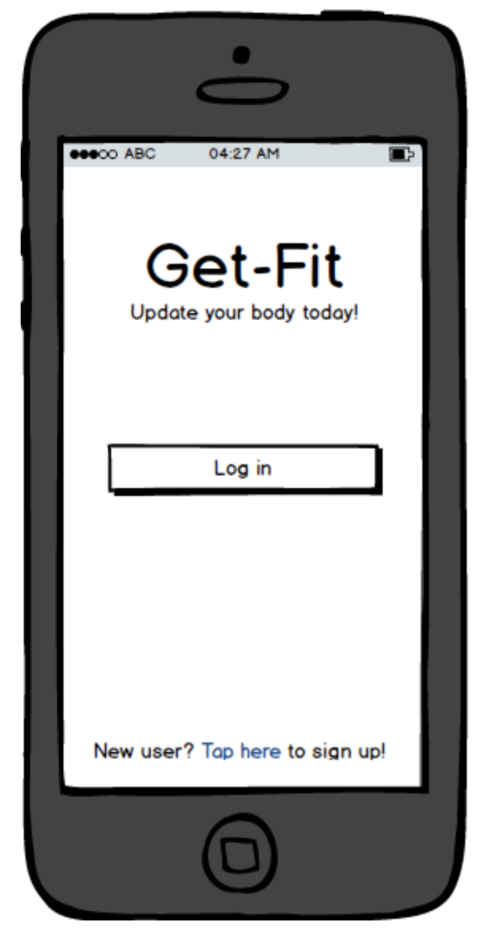

|  |  |
| --- | --- |
| i |  |
|  |  |
|  |  |
|  |  |
|  |  |
|  |  |

# Design evaluation

Concrete tasks for use in evaluation

1. Are you able to tell me the number of steps you have taken any day in the past month. (User Goal 2)
2. Tell me if you have taken more steps today in comparison to yesterday. (User 2)
3. Are you able to navigate to the Challenges page and tell me what the current challenge is. (User 4)
4. Tell me if you were able to meet your goal for the number of steps you took two days ago. (User Goal 1)
5. Are you able to navigate to the Music page and play a song. (User goal 3)
6. Can you please change the number of steps you aim to take monthly on the Settings page. (User 1)

//

# 

# Evaluation results

User backgrounds:

|  |  |  |  |  |  |  |  |  |
| --- | --- | --- | --- | --- | --- | --- | --- | --- |
|  | User 1  (Tom) | User 2  (Joe) | User 3  (Michaela) | User 4  (Jervis) | User 5  (sharmyn) | User 6  (Louis) | User 7  (Henry) | User 8  (lecture) |
| Age | 20 | 23 | 20 | 20 |  | 22 | 20 | 20 |
| Gender | M | F | M | F |  | M | M | M |
| INFO3315 Student | No | No | Yes | No |  | No | No | Yes |
| Completed high school | Yes | Yes | Yes | Yes |  | yes | Yes | Yes |

Interface performance data: Completed Completed with issues Did not complete

|  |  |  |  |  |  |  |  |  |
| --- | --- | --- | --- | --- | --- | --- | --- | --- |
|  | User 1 | User 2 | User 3 | User 4 | User 5 | User 6 | User 7 | User 8 |
| Task 1 |  |  |  |  |  |  |  |  |
| Task 2 |  |  |  |  |  |  |  |  |
| Task 3 |  |  |  |  |  |  |  |  |
| Task 4 |  |  |  |  |  |  |  |  |
| Task 5 |  |  |  |  |  |  |  |  |
| Task 6 |  |  |  |  |  |  |  |  |
| Task 7 |  |  |  |  |  |  |  |  |
| Task 8 |  |  |  |  |  |  |  |  |

Observation notes:

|  |  |
| --- | --- |
|  | Detailed observations |
| User 1 | Found task 1 confusing because could not locate the “profile page”. Was still able to complete profile editing, but within the settings page.  Found challenges page confusing, as “current” challenge was not defined. Only a list of in progress, completed or not started. User noted that their position on the leaderboard was displayed twice. Once for their current position (always displayed at top), and secondly in the leaderboard. |
| User 2 | From login page to setting page all make quick actions. A little bit confused in home screen. From home screen to leaderboard, user made quick actions without needing to absorb a lot of information. Took a small pause to read in activity page and took some time to explore the challenges page. |
| User 3 | A little bit confuse from the beginning, the user thought the login page and registration page quite complex for a app. But he found the data about previous activity soon, and all the rest task. |
| User 4 | User spend a few minutes in home screen and activity history page, because he had a little bit confused about goal progress and where the history is. The other pages were quickly accessed without any help. |
| User 5 |  |
| User 6 | User did not realise that the back button would make his use of the app more efficient, instead he would use the home button to restart each task. On the other hand, the user was impressed with the ideas of incorporating music and leaderboards as part of a fitness app to help encourage potential future users. |
| User 7 | Confusing the location of history record and content of setting page. Overall all tasks were completed without help, however data visualisation is lacking which causes user to be confuse in some areas. |
| User 8 |  |

Qualitative results:

|  |  |
| --- | --- |
|  | Summary of observations |
| User 1 | Profile editing needs to be made clearer and added to a separate “profile” page. Challenges page should not have a list, but should have 1 challenge that is the “current challenge” for them to work on. Homepage shows last 2 weeks compared, user was not sure why 2 weeks was the chosen period. |
| User 2 | User enjoys simplicity and minimalistic designs when it come to the interface. Assuming she would use it on her phone, she want it to look nice and cute while being clear and useful in tracking, monitoring and improving her physical activities. |
| User 3 | Setting page need to be simplified. Put the challenge page to the front will be better, is easy to change goals. User also recommend us to build a map page which can draw one-day rout. |
| User 4 | Activity history page is not clear to show which activity is start and which activity is in process and how about the process go. Activity page need to be more clear that which task need to be complete and when the task due. |
| User 5 |  |
| User 6 | Back button needs to be made more salient, possibly by using color grading. Possibly making a button to access the music page in the top left corner would make it more obvious that this is a feature. |
| User 7 | Setting page should only contain setting about the app like language, font or something else. User advise us to build some new pages should only have some signals like trophy, they can show to users what they have achieved. |
| User 8 |  |

# 

# Reflection

The Design Mockup  
Strength:  
1. Based on the comments of all the participants, the function of each screen page is clear and has no overlap.  
2. Based on the comments and the task 1 done by all the participants, they can find the basic information (like the step for today) easily.  
3. Based on the comments of P4, P1, the layout of our mockup is beautiful and clear.  
  
Weakness:  
1. Based on the task 3 done by P2, P3, the presentation form of the recommended goal (the red line) is not clear and confusing.

For the participant population:

Our persona is a University student studying Computer Science with low levels of physical activity. 7 out of 8 our participants are USYD students, another one is in UTS, and most of them are major in IT or CS. Half of them are with low levels of physical activity. Must be aware that the test user has a higher level of technical skill than the normal people.

For the tasks:

This interface design reflects the usefulness of the Activity and Homepage. Statistics data page is homepage, it could fulfil 70% of the abstract tasks. There are potential flaws in the achievement page that haven't been examined. Also, based on the task 3 done by P1, P2, the users can be confused about the homepage, the graph shows too much information for them.

For the process:

Most users never heard of think aloud before and didn’t know what to say during the test. During the think aloud, the users were a little bit nervous when we gave them the order to finish the tasks.